LIMIT SWITCH

CLZ-8104S

- 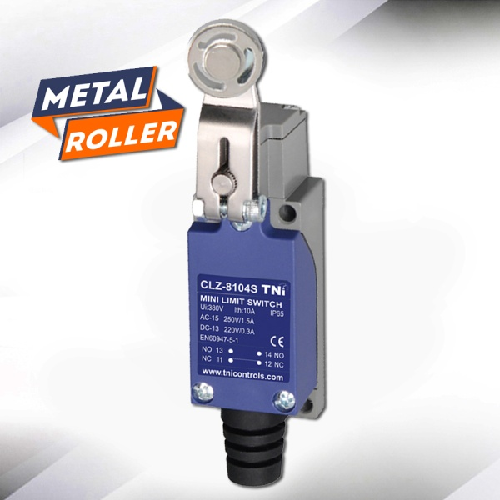

INPUT SPECIFICATIONS
Operating Speed | 0.5mm-50cm/sec
Operating Frequency | Mechanical: 120 Operating/minuts  Electrical : 30 Operations/minuts
Contact Resistance | 25mΩ min. (Initial Value)
Insulation Resistance | 100mΩ min. (below 500VDC)

OUTPUT SPECIFICATIONS
Dielectric Strength | 1000VAC, 50/60Hz for 1 minute between terminals of the same polarity
 | 1500VAC, 50/60Hz for 1 minute between current-carrying and non-current-carrying metal parts
 | 1500VAC, 50/60Hz for1 minute between each terminal and ground
Vibration | 10-55Hz,1.5mm double amplitude

ENVIRONMENT
Ambient Temperature | -5~ 65ºC (with no icing)
Humidity | ~95% RH
Life | Mechanical : 10 Million Operation above  Electrical : 500,000 Operation above
Shock | Mechanical durable : 1,000m/sec² (about 100G'S)  Malfunction : 300m/sec² (about 30G'S)

STANDARDS
Weight | About 130 to 190g
EMC Standards | EN60947-5-1
Degree Of Protection | IP65

Applications
Industrial Control Panel | Injection Moulding Machines
Elevator Control Panel | Industrial Machinery

